Azure API Management Integration

<https://learn.microsoft.com/en-us/azure/api-management/import-and-publish>

<https://support.smartbear.com/swaggerhub/docs/integrations/azure-api-management.html>

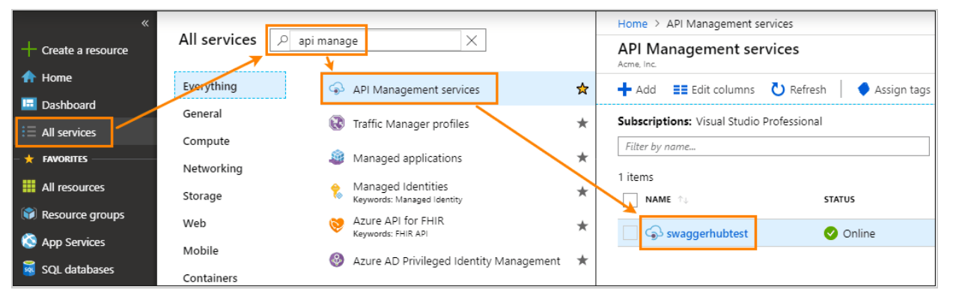

#### **Generate an Azure access token**

To generate an access token:

1. Open the Azure portal, [https://portal.azure.com](https://portal.azure.com/).
2. On the left, select **All resources**.

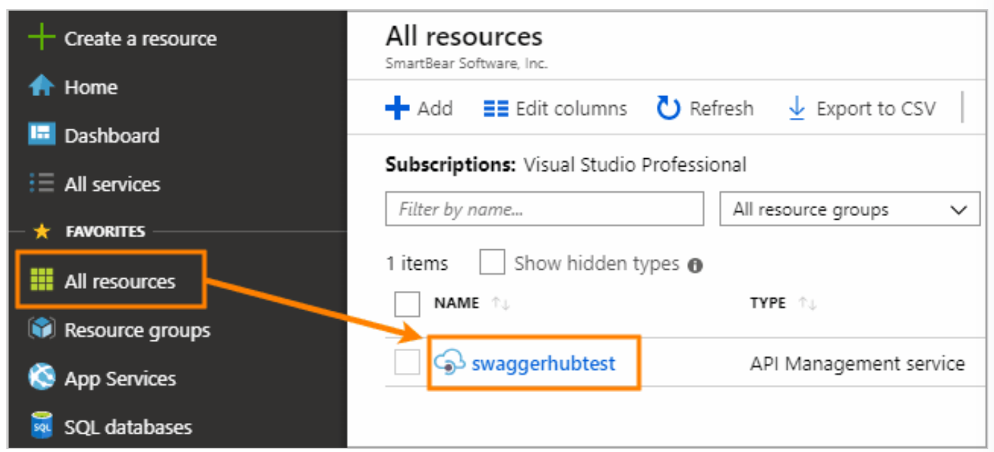

1. On the left, select **Management API**.
2. Select the **Enable API Management REST API** check box.
3. At the bottom, under **Access token**, click **Generat**

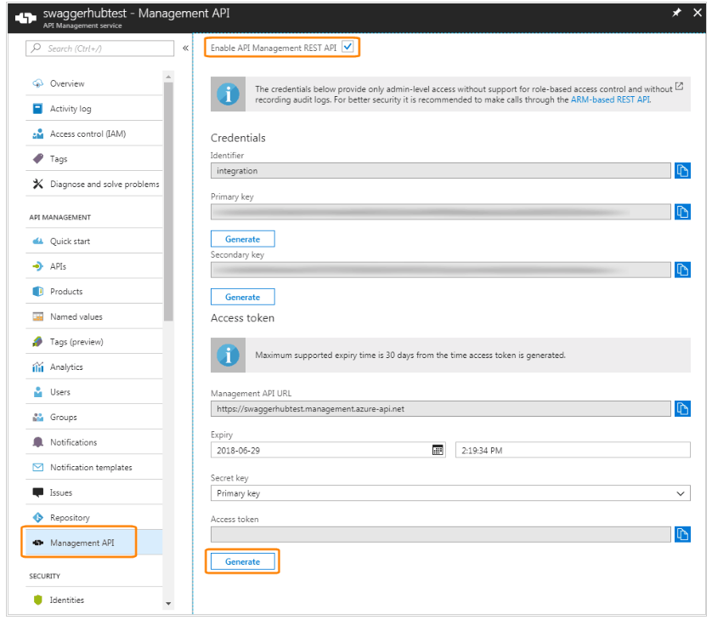

Copy the generated token (the entire string), because you will not be able to see it later.

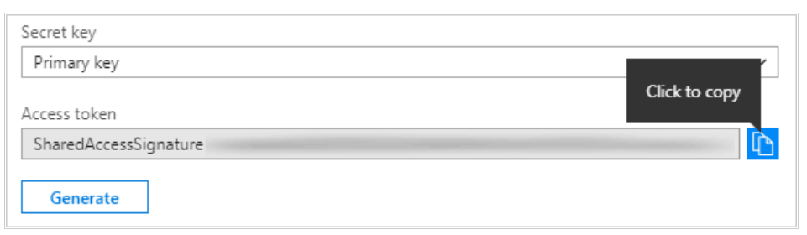

### **Configure the integration**

1. Open your API in the [SwaggerHub editor](https://support.smartbear.com/swaggerhub/docs/ui/editor.html).
2. If the API has several versions, select the version you want to push to Azure API Management.

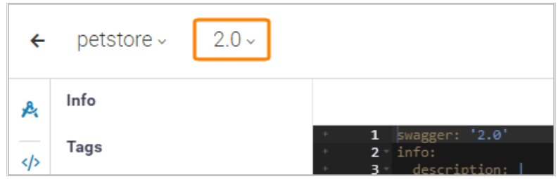

Click the Click API name, switch to the **Integrations** tab, and click **Add New Integrations**:

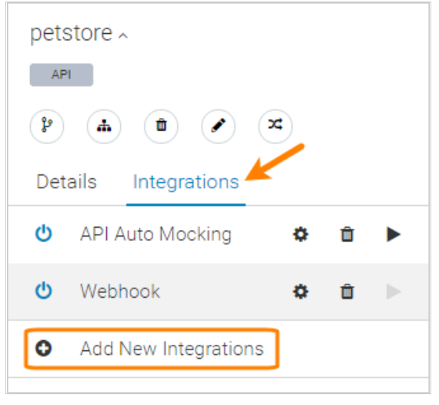

**Management API Access Token**

Click **Sign in with Microsoft**. You will be prompted to log into your Azure account and authorize the connection with SwaggerHub.